PRD: Dollar Tracker

PRD: Dollar Tracker

Vision

For personal finance enthusiasts, young professionals, entrepreneurs, and families seeking an effective way to manage their money and who must overcome financial disorganization, our Dollar Tracker is a new personal finance management app that provides a consolidated platform that helps you take control of your money. Dollar Tracker offers a user-centric, all-in-one solution by effortlessly capturing, categorizing, and tracking financial transactions, while offering customizable categories and intelligent budgeting features. Through seamless integration with multiple accounts, we simplify both personal and business finance management.

Motivation

The motivation for the Dollar Tracker app stems from the need to provide users with a comprehensive and user-friendly financial management tool. It aims to empower individuals to take control of their finances, manage expenses, and make informed financial decisions. The desire to create a more organized and efficient way for users to track their money and improve their financial well-being is the driving force behind this project.

Customer Segments:

Hypotheses regarding the likely profile of target customer segments may include:

- Emerging Professionals:

  - Demographics: Age 22-35, urban dwellers, tech-savvy.

  - Behaviors: Digital tool users, early in their careers.

  - Attitudes: Concerned about financial independence and future planning.

- Entrepreneurs and Freelancers:

  - Demographics: Business owners, self-employed.

  - Behaviors: Irregular income streams, managing personal and business finances.

  - Attitudes: Seek comprehensive financial solutions for both business and personal needs.

1
PRD: Dollar Tracker

- Families and Parents:

  - Demographics: Families with children, single parents.

  - Behaviors: Complex financial needs, budgeting for childcare and education.

  - Attitudes: Interested in family budgeting and future planning.

Unmet |  |  |  |  |  |  |  | Needs:
Hypotheses regarding unmet needs may include:
1. | Emerging |  |  |  | Professionals |  |  | :
 | Need: | Guidance | on | managing |  | loans | and | saving.
 | Pain: Struggling with financial independence and financial expectations.
2. | Entrepreneurs |  |  |  | and |  |  | Freelancers:
 | Need: Comprehensive financial management for both personal and business finances.
 | Pain: Juggling multiple accounts and complex income streams.
3. | Families |  |  |  | and |  |  | Parents:
 | Need: Tools for family budgeting and planning for children's education. Pain: Balancing
 | family finances, savings, and investment.

Evidence for Unmet Needs:

To validate the unmet needs of our target customer segments, we conducted user surveys and interviews with individuals from various demographic groups. Here's an example of the evidence we collected:

User Interview Excerpt:

Interviewee: John (Age 30), a young professional.

Unmet Need: Guidance on managing loans and financial independence.

Evidence:

John shared that he recently moved to a new city for work, and he's struggling to manage his finances independently.

He expressed his need for a tool that not only tracks expenses but also provides financial advice tailored to his specific situation.

John mentioned that existing apps like Mint and Expensify focus on expense tracking but lack the guidance aspect he's seeking.

2
PRD: Dollar Tracker

Existing Solutions:

We identified solutions such as Expensify, Mint, and Splitwise and assessed their suitability for comprehensive personal financial management. Here's our analysis:

Expensify:

Expensify is primarily designed It may not be the best choice for customization and financial advice.

for business expense tracking and report generation. personal budgeting because it lacks features like budget

Mint:

Mint is a well-known budgeting and cost tracking tool but offers limited flexibility in customizing

expense categories.

The free version of Mint displays ads, which can be intrusive for some users.

Splitwise:

Splitwise is designed for splitting expenses among friends or roommates, not for individual

personal finance management.

It lacks comprehensive budgeting features.

Differentiation:

The Dollar Tracker app distinguishes itself from the competition with a variety of cutting-edge features made to meet a variety of money management requirements. By utilizing artificial intelligence, it offers users tailored insights and suggestions to assist them in making wise financial decisions. Furthermore, the app is a great option for foreign users who have assets or transactions in other currencies because it enables multi-currency capabilities. The software has a secure document management function that enables users to save and retrieve critical documents safely, ensuring that users can maintain the organization of their financial papers. Security and privacy are of utmost importance, and the software takes strong precautions to protect user information. In addition, it makes joint budgeting easier, which makes it a great option for families or business partners who wish to handle money cooperatively. The software allows users to track their investment portfolios in real time if they are interested in investing. The software uses gamification features to make financial management more entertaining and to motivate users to make prudent investments and save money. Finally, Dollar Tracker is a flexible solution for individuals, families, business owners, and investors since it provides configurable reporting choices that let users create financial reports catered to their own needs.

3

PRD: Dollar Tracker

FEATURES | Expensify |  | Mint |  | Splitwise |  | Dollar Tracker
Target User | ● | Business | ● | Single | ● | Single | ● | Single users
 | ● | Employees |  | users |  | users | ● | Businesses
 |  |  |  |  | ● | Family | ● | Employees
 |  |  |  |  |  | groups
 |  |  |  |  | ● | Friend
 |  |  |  |  |  | groups
Primary Use | ● | Business | ● | Personal | ● | Splitting | ● | Personal finance
 |  | expense |  | budgeting |  | expenses |  | management
 |  | tracking | ● | Expense | ● | Tracking
 | ● | Reporting |  | tracking |  | expenses
Key Features | ● | Expense | ● | Budgeting | ● | Expense | ● | Expense
 |  | tracking | ● | Expense |  | splitting |  | tracking
 | ● | Receipt |  | tracking | ● | Balance | ● | Budget planning
 |  | capture | ● | Account |  | tracking | ● | Spending
 | ● | Approval |  | aggregatio | ● | Payment |  | analysis
 |  | workflows |  | n |  | reminders | ● | Link bank A/c
Strengths | ● | Streamlined | ● | Comprehen | ● | Expense | ● | Customizable
 |  | expense |  | sive |  | sharing |  | categories
 |  | tracking and |  | financial | ● | Balance | ● | Budget-friendly
 |  | reporting |  | overview |  | settlement |  | splitting
 | ● | Receipt | ● | Account | ● | Group | ● | Expense
 |  | Management |  | aggregation |  | managem |  | forecasting
 | ● | Approval |  |  |  | ent | ● | Spending
 |  | workflow |  |  |  |  |  | analysis
 |  |  |  |  |  |  | ● | Link bank A/c
 |  |  |  |  |  |  | ● | Income vs.
 |  |  |  |  |  |  |  | expense report
Security | ● | Bank-level | ● | Bank-level |  | None | ● | Bank-level
 |  | security | ● | security |  |  |  | security and
 |  |  |  | and |  |  |  | encryption
 |  |  |  | encryption
Bank Sync |  | Yes |  | Yes |  | No |  | Yes
Credit score |  | No |  | Yes |  | No |  | No
check
Drawbacks | ● | Business | ● | Limited | ● | Limited
 |  | focused |  | customization |  | features
 | ● | Complex for | ● | Intrusive ads | ● | Not for
 |  | personal use |  |  |  | personal
 |  |  |  |  |  |  |  | 4

PRD: Dollar Tracker

 |  |  |  | use
Pricing | Paid plan starting at | ● | Free with | Free | ● | Free with ads
 | $4.99/ month |  | ads. |  | ● | Paid plan for
 |  | ● | Paid plan for |  |  | $4.99/month
 |  |  | $4.99/month
Why Now:

The increasing prevalence of smartphones and digital tools, coupled with users' growing need for efficient financial management, makes this opportunity timely. Furthermore, advancements in technology enable real-time financial tracking and analysis.

Verbal/Visual Walkthrough of Use Cases

With Dollar Tracker's user-friendly tools and real-time information, Emma can easily manage transactions, set customized budgets, and meet savings targets as she progresses with her financial journey. By streamlining transaction recording, enabling group budgeting, and encouraging goal achievement, Dollar Tracker helps the Johnson family maintain financial harmony and has evolved into a vital tool for open and effective money management. Dollar Tracker proves to be a strategic ally in Alex's entrepreneurial pursuits, allowing effective cash allocation through the cash Adding tool and helping with workload management with the Smart Task Tracker, all while giving clarity and control over the obstacles of entrepreneurship.

Use Case: Emma's Financial Fitness Journey with Dollar Tracker (Emerging Professionals)

Introducing Emma, a young professional committed to using Dollar Tracker to manage her finances. Emma gets started right away by connecting her bank accounts and quickly enrolling, which makes transaction tracking simple. Emma creates a customized budget using Dollar Tracker's intuitive interface of goal tracker, assigning money to different categories such as grocery and recreation. Her transactions are automatically recorded by the app, which provides real-time spending behavior data. Emma is motivated by the goal-tracking function to save money for a future trip, and she uses interactive visualizations to track her progress. Emma is informed and motivated by Dollar Tracker's regular reports and notifications. The app recognizes her accomplishments as she reaches new benchmarks. Emma's usage of Dollar Tracker to make well-informed decisions has resulted in her increasing financial empowerment and realization of her financial goals.

5
PRD: Dollar Tracker

1. She signed-up for the first time 2. She chose the category as personal.
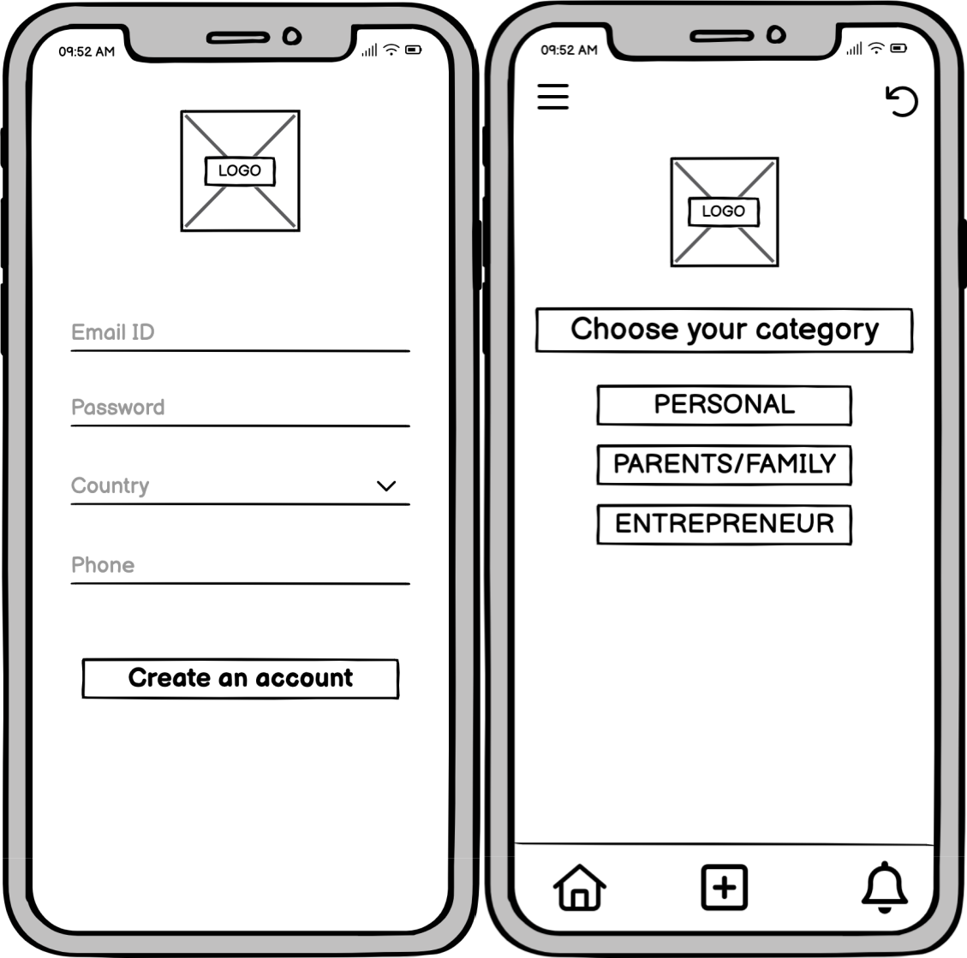

6
PRD: Dollar Tracker

3. She links her account. 4. Goes to main navigation tab.
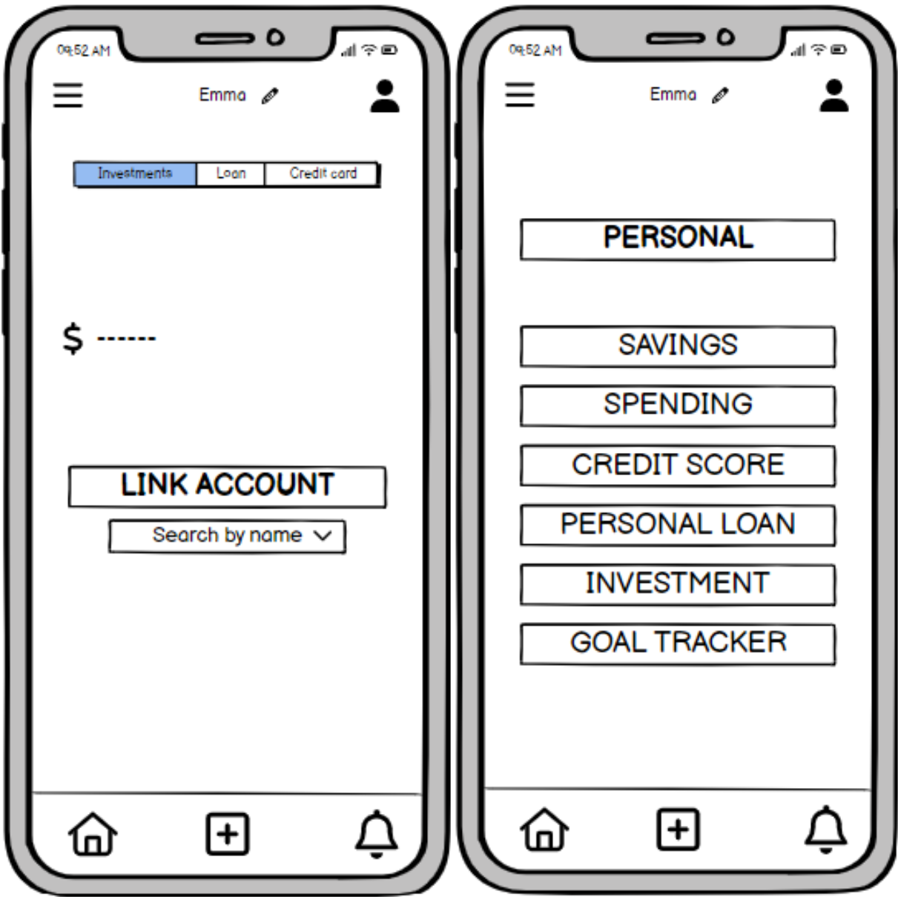

7
PRD: Dollar Tracker

5. She checks her saving Summary. 6. Track her goals by going into goal tracker.
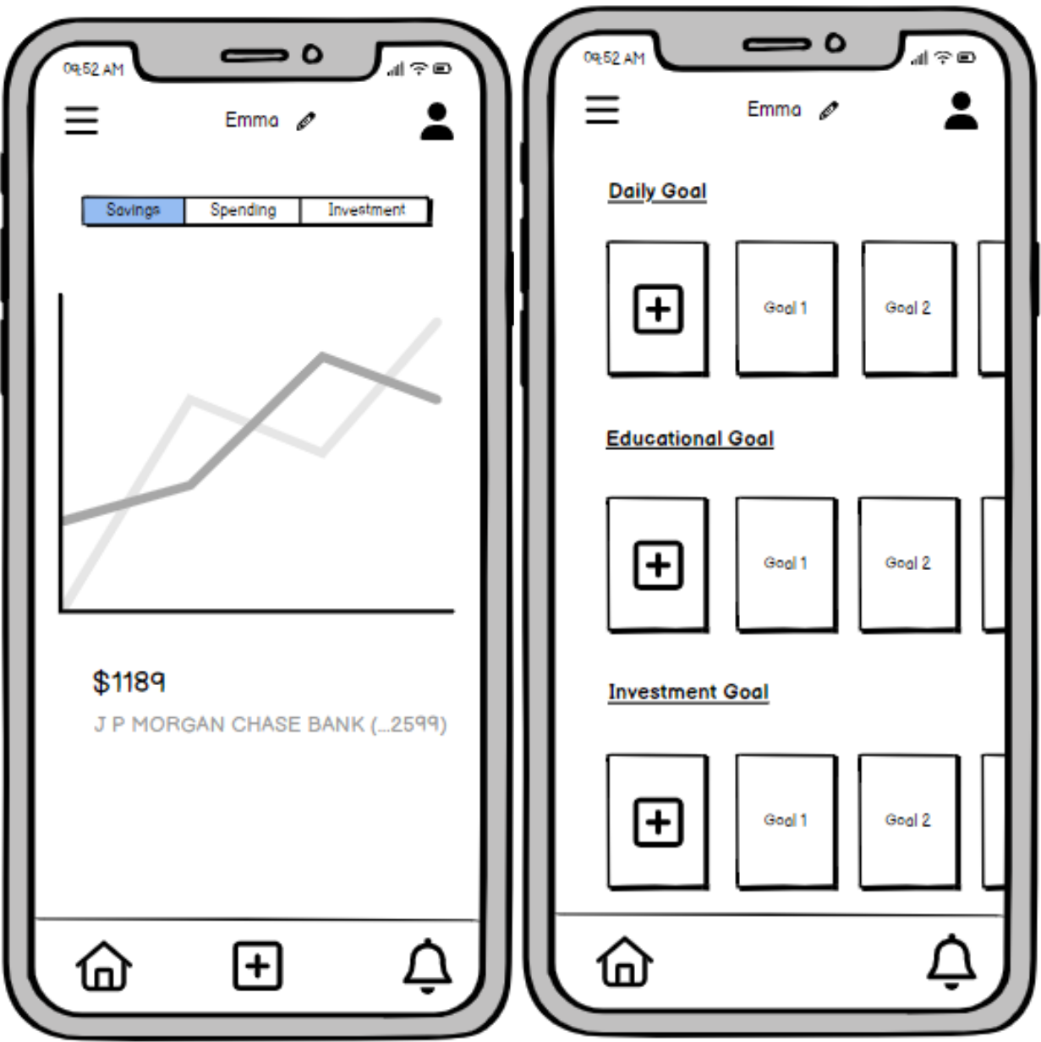

8
PRD: Dollar Tracker

7. She wants to add a goal. 8. She then checks her goal summary.
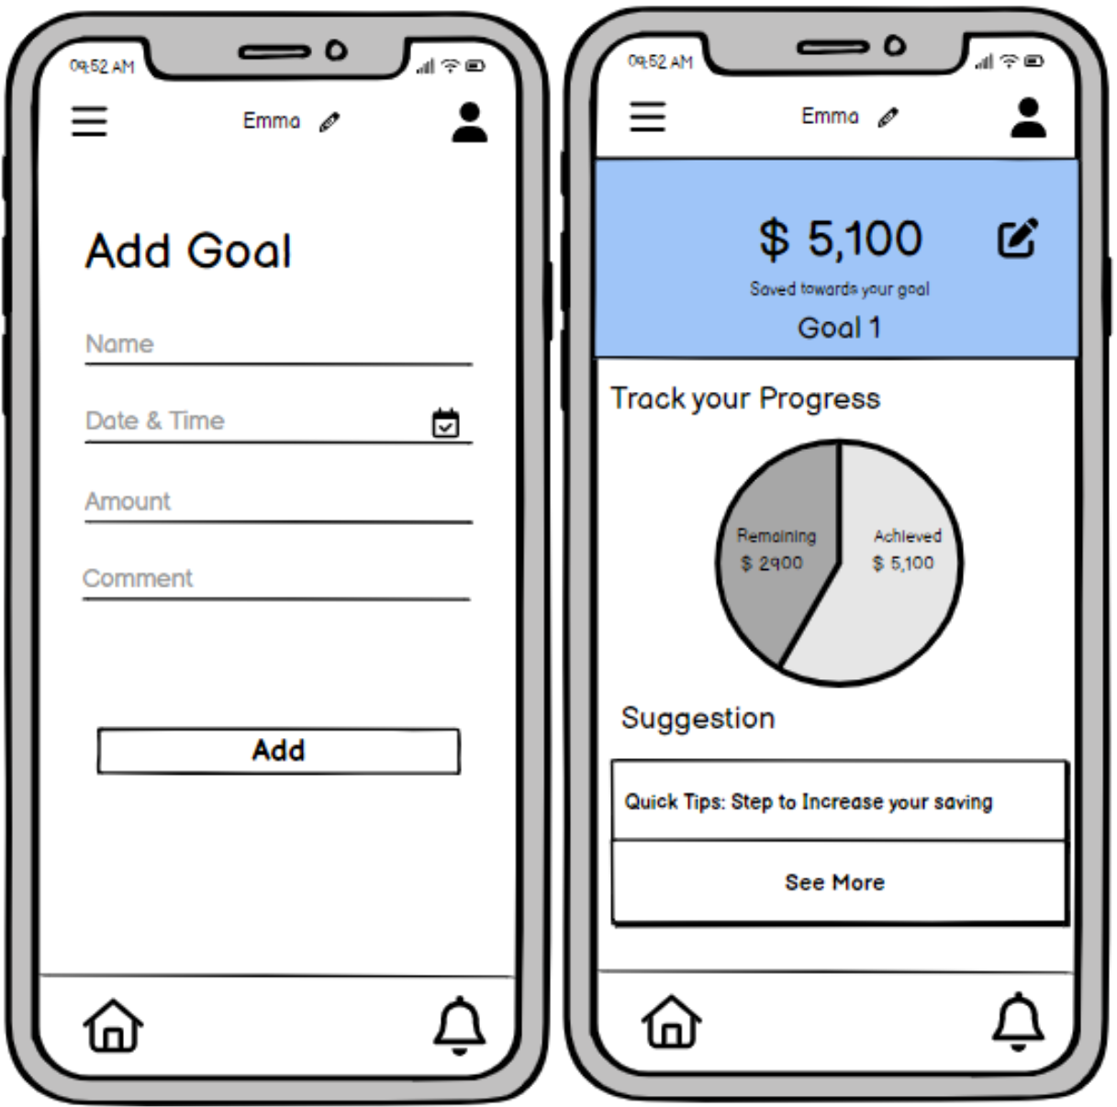

9
PRD: Dollar Tracker

Use Case: Johnsons Family Financial Harmony with Dollar Tracker (Parents and Families)

Dollar Tracker helps the Johnson family, a busy family with multiple financial commitments, find financial harmony. Every member of the family connects their accounts to facilitate transaction tracking, which makes handling money easy. Using the app's personalized budgeting tool, they create a family budget together and allocate money for shared savings objectives, groceries, and utilities. All expenses are tracked thanks to Dollar Tracker's automated transaction tracking, which reduces manual labor. With its picture of spending trends, the family-focused dashboard encourages candid conversations about financial goals. The Johnsons start saving for their ideal trip with the help of the goal-tracking feature, which provides them with real-time progress reports to keep them motivated. The ability of the upcoming dues features to track impending payments guarantees that no bill is overlooked, and the family is aware of their financial obligations thanks to timely reminders. As the Johnson family's financial transparency, cooperative saving, and goal-achieving success increase, Dollar Tracker turns into a vital tool.

1. Johnson navigates to Parent/ Family Tab 2. They add funds to their family savings.

and tracks their upcoming dues.
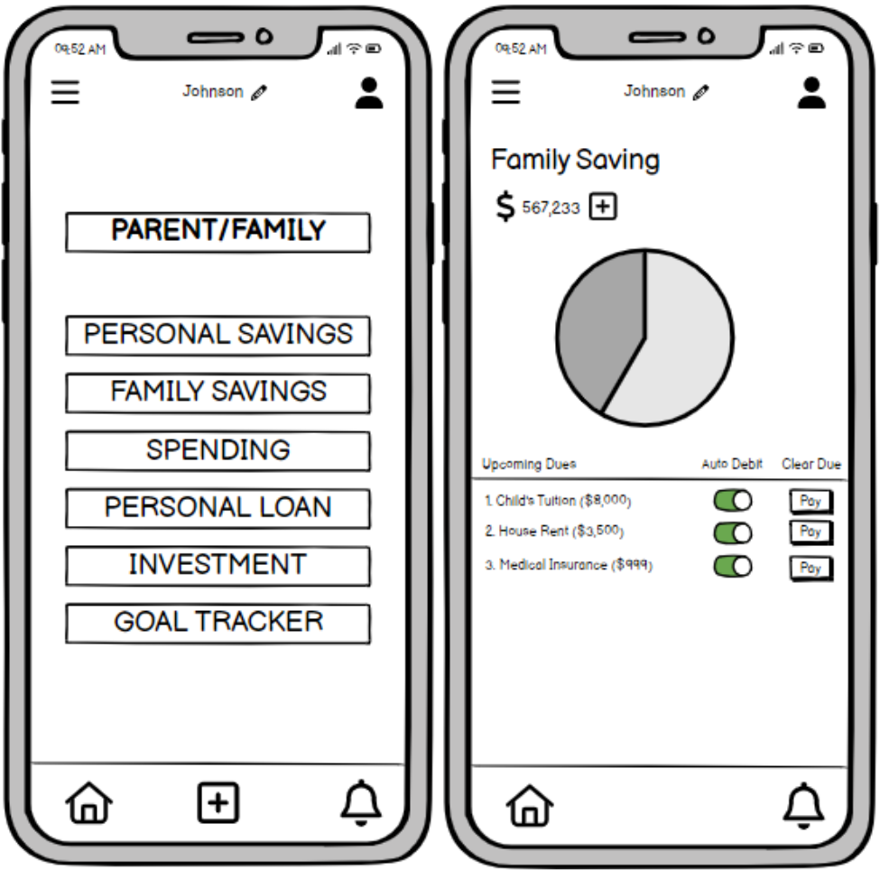

10
PRD: Dollar Tracker

3. They track their goal. 4. They check their goal summary.
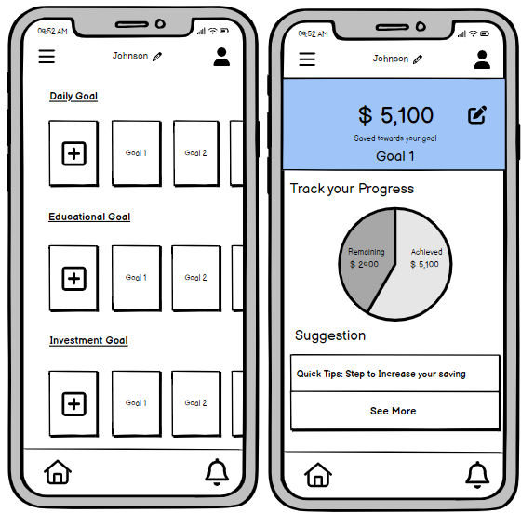

Use Case: Alex entrepreneur journey with Dollar Tracker (Entrepreneur and Freelancer)

Introducing Alex, a businessman with an eye toward effectiveness. An important part of Alex's business plan is Dollar Tracker. Through the Fund Adding feature of the app, Alex may easily allocate funds to various elements of his firm, such as marketing campaigns, operating expenses, or research and development. Updates on available cash are guaranteed in real time thanks to the app's interaction with business accounts. Furthermore, Alex can efficiently manage his workload with the help of the Smart Task Tracker tool. Alex may make the most of his time and resources by establishing goals and ranking tasks that pertain to expanding his company. Dollar Tracker becomes a thorough business partner as well as a financial instrument, giving Alex the clarity and control to successfully negotiate the challenges of entrepreneurship.

11
PRD: Dollar Tracker

1. Alex goes to Entrepreneur section. 2. He can add funds, track his task.
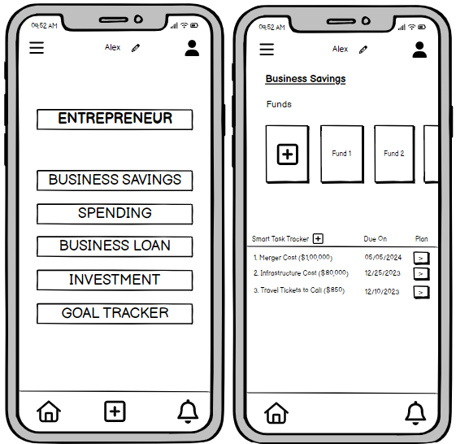

12
PRD: Dollar Tracker

Detailed Design & Features Description

Design Principles:

- User-Centric Design: Ensure the app's interface is intuitive and easy to navigate.

- Scalability and Modularity: Design the app with a scalable architecture to accommodate future features like gamification, data analytics, and document management.

- Security and Privacy: Implement security measures for data storage, especially when considering document management.

- Accessibility and Localization: Design with inclusivity in mind, ensuring the app is accessible to users with diverse abilities.

- Feedback-Driven Iteration: Incorporate user feedback loops into the design process

Features architecture:

Feature | Description | Working |  |  |  | Dependency |  | Priority
Real-time | Track and analyze | Utilizes live data |  |  |  | No dependencies on |  | High
Expense | your expenses in | feeds to provide |  |  |  | other features in the v1
Tracking | real time. | users with |  |  |  | MVP.
 |  | immediate insights
 |  | into their spending
 |  | habits. Users can
 |  | categorize
 |  | expenses as they
 |  | occur, enabling
 |  | real-time tracking
 |  | and analysis.
Create and | Create and | Allows | users |  | to | Dependent on the basic |  | High
Categorize | categorize | manually |  | input |  | expense | analytics
Transactions | transactions easily. | transactions |  |  | and | feature to | categorize
 |  | categorize |  | them |  | transactions effectively.
 |  | for |  | better
 |  | organization. This
 |  | feature |  | ensures
 |  | that users |  |  | can
 |  | easily maintain an
 |  | accurate record of
 |  | their | financial
 |  | activities |  | within

13
PRD: Dollar Tracker

 |  | the app.
Goal Tracker | Set and track | Enables |  | users |  | to | Partial dependency on |  |  | Medium
 | financial goals. | define and monitor |  |  |  |  | basic expense analytics
 |  | specific |  | financial |  |  | to | align | goals with
 |  | objectives. |  |  | Users |  | current financial status.
 |  | can | set |  | goals
 |  | related to savings,
 |  | investments, |  |  |  | or
 |  | debt reduction, and
 |  | the | app | provides
 |  | progress |  | tracking
 |  | and insights to help
 |  | achieve |  |  | these
 |  | goals.
Basics Expense | Get basic analytics | Provides |  |  | users |  | No | direct | dependencies | Medium
Analytics | of your expenses. | with | fundamental |  |  |  | for v1 MVP features.
 |  | analytics, such |  |  |  | as
 |  | expense
 |  | summaries |  |  |  | and
 |  | trends, |  | based |  | on
 |  | their |  | recorded
 |  | transactions. |  |  | This
 |  | feature |  | serves |  | as
 |  | the foundation |  |  |  | for
 |  | more |  | advanced
 |  | analytics |  | in | future
 |  | updates.
 |  |  |  |  |  |  |  |  |  | 14

PRD: Dollar Tracker

User | Get | help | getting |  | Guides |  | new |  | users |  | No direct |  | dependencies |  |  |  | Medium
Onboarding and | started with the app |  |  |  | through |  | the |  | app's |  | for v1 MVP features.
Tutorials | and | learn | how | to | functionalities,
 | use its features. |  |  |  | ensuring a smooth
 |  |  |  |  | onboarding
 |  |  |  |  | experience.
 |  |  |  |  | Tutorials |  |  | explain
 |  |  |  |  | the | process |  |  |  | of
 |  |  |  |  | creating
 |  |  |  |  | transactions,
 |  |  |  |  | tracking |  | expenses,
 |  |  |  |  | and utilizing |  |  |  | basic
 |  |  |  |  | analytics.
Future Expense | Track and analyze |  |  |  | Enables |  | users |  |  | to | Partial | dependency |  |  |  | on | Medium
Tracking | your | expenses |  | in | plan | and |  | project |  |  | basic | expense |  | analytics
 | the future. |  |  |  | future |  | expenses |  |  |  | to project |  | future |  | trends
 |  |  |  |  | based on historical |  |  |  |  |  | accurately.
 |  |  |  |  | data. | This |  | feature
 |  |  |  |  | provides |  |  | insights
 |  |  |  |  | into |  | potential
 |  |  |  |  | future |  | financial
 |  |  |  |  | scenarios, |  |  | helping
 |  |  |  |  | users |  |  | make
 |  |  |  |  | informed
 |  |  |  |  | decisions.
Gamification | Add | gamification |  |  | Introduces |  |  | game- |  |  | Dependency |  |  | on | basic |  | Low
Elements | elements |  | to | the | like | elements |  |  |  | to | expense |  | analytics |  |  | for
 | app, such as badges |  |  |  | encourage |  |  |  | user |  | establishing achievement
 | and | leaderboards, |  |  | engagement. Users |  |  |  |  |  | milestones.
 | to make |  | it more |  | earn | badges |  |  |  | for
 | engaging |  | and | fun | achieving financial
 | for users. |  |  |  | milestones, |  |  |  |  | and
 |  |  |  |  | leaderboards foster
 |  |  |  |  | friendly
 |  |  |  |  | competition among
 |  |  |  |  | users.

15
PRD: Dollar Tracker

Data Analytics | Use data analytics |  |  | Analyzes |  |  |  | user |  | Dependency on real-time |  |  |  | Medium
 | to understand user |  |  | interaction patterns |  |  |  |  |  | expense | tracking |  | to
 | behavior |  | and | to enhance |  |  |  |  | the | gather live user data for
 | identify | new |  | app's | features |  |  |  | and | analysis.
 | opportunities |  | to | functionality
 | improve the app. |  |  | continuously.
 |  |  |  | Helps |  |  | identify
 |  |  |  | trends |  |  |  |  | and
 |  |  |  | preferences,
 |  |  |  | informing |  |  |  | future
 |  |  |  | updates |  |  |  |  | and
 |  |  |  | optimizations.
Document | Begin |  |  | Allows |  | users |  |  | to | Dependency |  | on | basic | Low
Management | development |  | for | securely |  | store |  |  | and | expense | analytics |  | for
 | secure | document |  | retrieve |  | financial |  |  |  | categorization |  |  | and
 | storage |  | and | documents |  |  | within |  |  | relevance | to | financial
 | retrieval. |  |  | the app, enhancing |  |  |  |  |  | documents.
 |  |  |  | its | utility |  |  |  | for
 |  |  |  | comprehensive
 |  |  |  | financial
 |  |  |  | management.
Expanded | Include support for |  |  | Enhances the app's |  |  |  |  |  | Dependency on real-time |  |  |  | High
Integration | a wider | range | of | utility by allowing |  |  |  |  |  | expense | tracking |  | for
 | financial | accounts |  | users to integrate a |  |  |  |  |  | seamless integration with
 | and institutions. |  |  | broader |  | spectrum |  |  |  | diverse |  | financial
 |  |  |  | of |  | financial |  |  |  | accounts.
 |  |  |  | accounts |  |  |  |  | and
 |  |  |  | institutions,
 |  |  |  | providing |  |  | a | more
 |  |  |  | comprehensive
 |  |  |  | overview |  |  | of | their
 |  |  |  | financial
 |  |  |  | landscape.

16
PRD: Dollar Tracker

AI-Powered | Use AI to provide |  |  |  | Leverages artificial |  |  |  |  | Dependency |  |  | on | data | High
Financial Insights | users |  |  | with | intelligence |  |  |  | to | analytics |  | to | refine | and
 | personalized |  |  |  | analyze |  | user |  | data | improve |  | AI | algorithms
 | financial |  | insights, |  | and |  | deliver |  |  | based on user behavior.
 | such | as | spending |  | personalized
 | recommendations |  |  |  | recommendations,
 | and | investment |  |  | enhancing |  |  | users'
 | advice. |  |  |  | financial |  | decision-
 |  |  |  |  | making
 |  |  |  |  | capabilities.
Chatbot Support | Add | a chatbot to |  |  | Implements |  |  |  | a | Partial | dependency |  |  | on | Low
 | the app to provide |  |  |  | chatbot for instant |  |  |  |  | basic | expense analytics
 | users |  |  | with | customer |  | support, |  |  | for |  |  | contextual
 | customer |  | support |  | addressing |  |  |  | user | understanding |  |  | of | user
 | and | answer |  | their | queries | related to |  |  |  | queries.
 | questions |  |  | about | app functionalities,
 | their finances. |  |  |  | transactions, |  |  |  | and
 |  |  |  |  | financial advice.
Expand into | Expand |  | the | app | Adapts the app to |  |  |  |  | Dependency |  |  |  | on | High
International | into | international |  |  | different |  |  |  |  | expanded |  |  | language
Markets | markets to reach a |  |  |  | international |  |  |  |  | options for localization in
 | wider audience. |  |  |  | financial |  | systems |  |  | diverse regions.
 |  |  |  |  | and | regulations,
 |  |  |  |  | enabling |  | a | global
 |  |  |  |  | user base.
Expand | Expand |  | language |  | Allows |  | users |  | to | No direct dependencies |  |  |  |  | Low
Language | options to reach a |  |  |  | customize the |  |  |  | app | on other features.
Options | wider audience. |  |  |  | interface |  | in | their
 |  |  |  |  | preferred
 |  |  |  |  | language, fostering
 |  |  |  |  | inclusivity |  |  |  | and
 |  |  |  |  | accessibility.

17
 | PRD: Dollar Tracker
v1 aka Minimum Viable Product (MVP)
Feature | Description
Real time expense Tracking | Track and analyze your expenses in real time.
Create and categorize transactions | Create and categorize your transactions easily.
Basics expense analytics | Get basic analytics of your expenses.
User onboarding and tutorials | Get help getting started with the app and learn
User onboarding and tutorials | how to use its features
Future expense Tracking | Track and analyze your expenses in the future.

vNext

Feature | Description
 | Add gamification elements to the app, such as
Add gamification elements | badges and leaderboards, to make it more
 | engaging and fun for users.
 | Use data analytics to understand user behavior
Add data analytics | and identify new opportunities to improve the
 | app.
Document Management | Begin development for secure document
Document Management | storage and retrieval.
Expanded Integration | Include support for a wider range of financial
Expanded Integration | accounts and institutions.

18
 | PRD: Dollar Tracker
vLong term
Feature | Description
 | Use AI to provide users with personalized
Add AI-powered financial insights | financial insights, such as spending
 | recommendations and investment advice.
 | Add a chatbot to the app to provide users with
Add chatbot support | customer support and answer their questions
 | about their finances.
Expand into international markets | Expand the app into international markets to
Expand into international markets | reach a wider audience
 | Expand Language options to reach a wider
Expand Language Options | audience

19
PRD: Dollar Tracker

Roadmap/Timing

QUARTER 1: ONBOARDING AND UI REFINEMENT

 |  |  | GOAL |  |  |  |  | MILESTONE
 | January - March: Onboarding Optimization |  |  |  | Milestone 1: Internal Demo of Simplified
 |  |  |  |  | Onboarding Process
 |  |  |  |  | Milestone 2: Beta Launch with Enhanced
 |  |  |  |  | Course Material
 |  |  |  |  | Reassessment Point: Collect user feedback on
 |  |  |  |  | the new onboarding experience.
 | April - June: UI Modernization |  |  |  | Milestone 3: Internal Demo of Updated
 |  |  |  |  | Interface
 |  |  |  |  | Milestone 4: Beta Launch with Improved
 |  |  |  |  | Navigation
 |  |  |  |  | Reassessment |  |  | Point: |  |  |  | Analyze | user
 |  |  |  |  | satisfaction and navigation metrics.
 | July - September: Quick Access Features |  |  |  | Milestone 5: Internal Demo of Dashboards
 |  |  |  |  | with Customizable Widgets
 |  |  |  |  | Milestone 6: Beta Launch of Quick Access
 |  |  |  |  | Features
 |  |  |  |  | Reassessment Point: Evaluate time reduction
 |  |  |  |  | in obtaining financial insights.

QUARTER 2: FEATURE INTEGRATION AND EXPANSION

 | GOAL |  |  |  |  |  | MILESTONE
 | October - December: Budgeting Module |  |  | Milestone 7: Internal Demo of Budgeting
 |  |  |  | Tools
 |  |  |  | Milestone 8: Beta Launch with Expense
 |  |  |  | Tracking and Budgeting Options
 |  |  |  | Reassessment Point: Monitor adoption rates
 |  |  |  | and user feedback.
 |  |  |  | 20

 |  |  |  |  |  |  |  |  |  |  |  |  |  |  | PRD: Dollar Tracker
 | January - March: Third-Party Integration |  |  |  |  |  | Milestone 9: Internal Demo of API
 |  |  |  |  |  |  | Integration
 |  |  |  |  |  |  | Milestone 10: Beta Launch with Two
 |  |  |  |  |  |  | Financial Institutions Integrated
 |  |  |  |  |  |  | Reassessment Point: Ensure smooth data
 |  |  |  |  |  |  | synchronization and security compliance.
 | April - June: Improvement of Expense |  |  |  |  |  | Milestone 11: Internal Demo of Machine
 | Categories |  |  |  |  |  | Learning Algorithms
 |  |  |  |  |  |  | Milestone 12: Beta Launch with Enhanced
 |  |  |  |  |  |  | Expense Categorization
 |  |  |  |  |  |  | Reassessment |  |  | Point: |  |  |  |  | Measure accuracy
 |  |  |  |  |  |  | improvement and user acceptance.
 | QUARTER 3: APP SECURITY AND PERFORMANCE ENHANCEMENT
 |  |  |  | GOAL |  |  |  |  |  | MILESTONE
 | July - September: Optimizing Performance |  |  |  |  |  | Milestone 13: Internal Demo of Reduced App
 |  |  |  |  |  |  | Load Times
 |  |  |  |  |  |  | Milestone 14: Beta Launch with Improved
 |  |  |  |  |  |  | Performance
 |  |  |  |  |  |  | Reassessment |  |  | Point: |  |  |  |  | Evaluate |  | user
 |  |  |  |  |  |  | experience |  |  | metrics |  |  |  |  | and | performance
 |  |  |  |  |  |  | improvements.
 | October - December: Multiple-Factor |  |  |  |  |  | Milestone 15: Internal Demo of Multi-Factor
 | Verification |  |  |  |  |  | Authentication
 |  |  |  |  |  |  | Milestone 16: Beta Launch with Enhanced
 |  |  |  |  |  |  | Security Measures
 |  |  |  |  |  |  | Reassessment |  |  | Point: |  |  |  |  | Assess | user | trust
 |  |  |  |  |  |  | improvement and security robustness.
 |  |  |  |  |  |  |  |  |  |  |  |  |  |  |  |  | 21

PRD: Dollar Tracker

 | January - March: Data Protection and |  |  |  |  |  | Milestone 17: Internal Demo of Automatic
 | Restoration |  |  |  |  |  | Data Backup
 |  |  |  |  |  |  | Milestone 18: Beta Launch with Data
 |  |  |  |  |  |  | Protection Features
 |  |  |  |  |  |  | Reassessment |  |  |  |  |  |  |  | Point: |  |  |  |  | Verify | data | loss
 |  |  |  |  |  |  | reduction and recovery capability.
 | QUARTER 4: ANALYTICS AND USER FEEDBACK INTEGRATION
 |  |  |  | GOAL |  |  |  |  |  |  |  |  |  |  | MILESTONE
 | April - June: Dashboard for Advanced |  |  |  |  |  | Milestone 19: Internal Demo of Financial
 | Analytics |  |  |  |  |  | Dashboards
 |  |  |  |  |  |  | Milestone 20: Beta Launch with Advanced
 |  |  |  |  |  |  | Analytics
 |  |  |  |  |  |  | Reassessment |  |  |  |  |  |  |  | Point: |  |  |  |  | Evaluate |  | user
 |  |  |  |  |  |  | engagement and feedback on analytics
 |  |  |  |  |  |  | features.
 | July - September: Integration of User |  |  |  |  |  | Milestone 21: Internal Demo of User
 | Feedback |  |  |  |  |  | Feedback System
 |  |  |  |  |  |  | Milestone 22: Beta Launch with Improved
 |  |  |  |  |  |  | Feedback Mechanism
 |  |  |  |  |  |  | Reassessment Point: Aim for a 20% response
 |  |  |  |  |  |  | rate and assess the effectiveness of the
 |  |  |  |  |  |  | feedback system.
 | October - December: Chat Support for Apps |  |  |  |  |  | Milestone 23: Internal Demo of In-App Chat
 |  |  |  |  |  |  | Assistance
 |  |  |  |  |  |  | Milestone 24: Full Launch with Chat Support
 |  |  |  |  |  |  | Implemented
 |  |  |  |  |  |  | Reassessment |  |  |  |  |  |  |  | Point: |  |  |  |  | Monitor | customer
 |  |  |  |  |  |  | satisfaction and accessibility with the new
 |  |  |  |  |  |  | chat support.

Alpha Testing Phase: limited rollout to internal stakeholders and a select group of early adopters for rigorous testing and feedback.

Beta Launch: Expanded release to a larger user base for comprehensive testing, incorporating feedback and fine-tuning features.

22
PRD: Dollar Tracker

Full Launch: Comprehensive rollout to the entire target user population, accompanied by marketing campaigns, leveraging insights gained from alpha and beta phases.

This roadmap allows for gradual feature integration, user feedback incorporation, and strategic reassessment points to ensure the Dollar Tracker app evolves in response to user needs and market dynamics.

Metrics

Our primary metrics for the success of the app would be:

- Monthly Net Saving: The primary indicator of the app's influence on users' financial success and well-being is the monthly net saving metric, which shows the total monthly savings made by users via prudent budgeting and money management.

- Customer Acquisition Cost (CAC): The Customer Acquisition Cost (CAC) is a critical metric for assessing how well an app's user acquisition techniques align with its long-term financial viability and expansion. It is the total costs related to gaining a new customer.

- Daily Active Users (DAU): Measurement of the number of unique users actively engaging with the app on a daily basis. It will Indicate the app's popularity and user engagement.
- Annual Revenue Per User (ARPU): An important financial indicator to evaluate the app's revenue-generating effectiveness and user value is Annual Revenue Per User (ARPU), which measures the average money earned from each user over a one-year period.

- Retention Rate: Track the percentage of users who continue to use the app over time, reflecting user satisfaction and the app's ability to retain its user base.

- Growth in Linked Bank Accounts: Monitor the increase in the number of bank accounts linked to the app, showcasing the app's expanding user base and financial integration.

Secondary Metrics that would be considered:

- Session Duration: Measure the average time users spend within each app session, providing insights into user engagement and app stickiness.

- Social Shares: Track the number of times users share app content on social media platforms, indicating user advocacy and organic growth potential.

- Bounce Rate: Assess the percentage of users who exit the app after viewing a single page, helping to identify user experience issues and potential improvements.

- Number of User Actions per Session: Count the total actions (e.g., expense entries, account interactions) users perform in a single session, gauging user activity and app feature engagement.

- Number of Sessions per User: Measure how frequently users open the app, providing insights into user habits and the app's integration into their daily routine.

- Traffic: Analyze overall app visits and user interactions, offering a comprehensive view of the app's popularity and usage patterns.

23
PRD: Dollar Tracker

- Net Promoter Score (NPS): Evaluate user satisfaction and loyalty by measuring the likelihood of users recommending the Dollar Tracker app to others.

- Upcoming Expense Alerts Response Rate: Monitor how users respond to upcoming expense alerts, indicating the effectiveness of the app's proactive financial management features.

- Customer Satisfaction Score (CSAT): Assess user satisfaction through direct feedback, providing a quantitative measure of users' overall experience with the Dollar Tracker app.

International

In-depth market research, localization, currency adaptation, legal compliance, cultural sensitivity, and time zone considerations are all part of the plan to internationalize Dollar Tracker. Over the course of 24 months, the timeline will be phased in, starting with English-speaking markets and working its way up to non-English-speaking ones. Navigating legal complexities, culturally aligning the features of the app, managing multiple currencies, offering efficient customer support across time zones, and guaranteeing continued relevance in a variety of international financial landscapes are among the main challenges. Achieving success requires careful planning, ongoing adaptation, and a dedication to satisfying the distinct requirements of users in each target market via frequent updates and user input.

Projected Costs

The Dollar Tracker app aims to capture the expense tracking market in Boston, targeting working professionals, small business owners, and small families. The estimated market potential is $3.36 million per year based on a calculated user base of 56,000 and a monthly subscription fee of $5. Here's a Cost breakdown of development of the dollar tracker app. Development Time: We anticipate a dedicated team for Dollar Tracker, consisting of four co-founders who will not take a salary during the early stages of the project. For a complex app like Dollar Tracker, it will take around 8 months.

Other Costs: Including other costs such as software licenses, marketing expenses, office space, utilities, etc.

24
 |  |  |  |  |  |  |  |  |  |  |  |  |  |  | PRD: Dollar Tracker
Labor Cost:
 |  |  |  |  |  |  |  |  |  |  |  |  | Duration |  |  |  |  | Estimated
Labor |  |  |  |  | Manpower |  |  |  | Average Hourly |  |  |  |  |  |  |  |  | Expense
 |  |  |  |  |  |  |  |  |  |  |  |  | (Estimated)
 |  |  |  |  |  |  |  |  | Wage |  |  |  |  |  |  |  |  | (3 months)
Product Manager |  |  |  |  | 1 |  |  |  | $60 |  |  |  | 8 months |  |  |  |  | $72,800
Software Architect |  |  |  |  | 2 |  |  |  | $60 |  |  |  | 8 months |  |  |  |  | $123,600
Database Administrator |  |  |  |  | 1 |  |  |  | $40 |  |  |  | 8 months |  |  |  |  | $41,200
Software Engineer |  |  |  |  | 3 |  |  |  | $50 |  |  |  | 8 months |  |  |  |  | $54,000
UX/UI designers |  |  |  |  | 2 |  |  |  | $45 |  |  |  | 8 months |  |  |  |  | $47,600
 |  |  |  |  |  | Total |  |  |  |  |  |  |  |  |  |  |  | $339,200
Infrastructure and Maintenance Cost:
Expenses |  |  |  |  |  | Cost |  |  |  |  |  | Duration |  |  |  |  |  | Total
App Store |  |  |  |  | $119 / year |  |  |  |  |  |  | 8 months |  |  |  |  |  | $119
Play Store |  |  |  |  | $35 one time-fee |  |  |  |  |  |  | 8 months |  |  |  |  |  | $35
Payment Gateways |  |  |  |  | $170 / month |  |  |  |  |  |  | 8 months |  |  |  |  |  | $1360
Patent fee |  |  |  |  | $7000 one-time fee |  |  |  |  |  |  |  |  |  |  |  |  | $7,000
 |  |  |  |  |  | Total |  |  |  |  |  |  |  |  |  |  |  | $8,514
IT Equipment Cost:
Equipment |  |  |  |  |  | Cost of Procurement |  |  |  |  |  | Requirement |  |  |  |  |  | Total
Mobile phones for testing |  |  |  |  |  | $700 |  |  |  |  |  | 3 |  |  |  |  |  | $2100
Laptops |  |  |  |  |  | $1000 |  |  |  |  |  | 9 |  |  |  |  |  | $9,000
 |  |  |  |  |  | Total |  |  |  |  |  |  |  |  |  |  |  | $30,000
Software Licensing Cost:
Software/Services |  |  |  |  |  | Cost |  |  |  |  | Requirement |  |  |  |  |  |  | Total
MongoDB |  |  |  |  | $57/month |  |  |  |  |  |  | 6 |  |  |  |  |  | $2,736
Jira cloud |  |  |  |  | $14/month/user |  |  |  |  |  |  | 5 |  |  |  |  |  | $560
MS office 365 |  |  |  |  | $23/year/user |  |  |  |  |  |  | 9 |  |  |  |  |  | $207
ExpressJS |  |  |  |  | Free
Mobile Angular |  |  |  |  | Free
 |  |  |  |  |  | Total |  |  |  |  |  |  |  |  |  |  |  | $3,503
 |  |  |  |  |  |  |  |  |  |  |  |  |  |  |  |  |  | 25

PRD: Dollar Tracker

- Labor Cost: $339,200

- IT Equipment Cost: $30,000

- Software Licensing Cost: $3,503

- Infrastructure + Maintenance Cost: $6,500

- Miscellaneous Cost: $7,000

- Total Projected Cost = $386,203

Operational Needs

The creation of a user support system, with features like a helpdesk, FAQs, and maybe live chat to handle user questions and offer troubleshooting assistance, is essential operational support for the Dollar Tracker product. Furthermore, specialized sources are required to ensure the authenticity and dependability of financial data by compiling and updating it from outside sources. Contractors are crucial, especially developers for continual maintenance and security specialists for constant evaluation and improvement of platform security. Limited resources will be allocated for the initial setup, user assistance, and data aggregation. There will also be a continuous commitment to answer changing needs, preserve data quality, and guarantee platform security through frequent reviews and modifications.

Addressing Caveats/Risks

 |  |  | RISK |  |  | MITIGATION PLAN
 | Privacy Concerns |  |  |  |  | Implement stringent security measures
 | Risk of privacy breaches and data security |  |  |  |  | like encryption, two-factor authentication,
 | threats due to sensitive financial data. Users |  |  |  |  | and conduct regular security audits to
 | may be hesitant to share financial information. |  |  |  |  | safeguard user data.
 | Legal and Compliance Risks |  |  |  |  | Conduct in-depth research and seek legal
 | Risk of non-compliance with financial |  |  |  |  | counsel to ensure full compliance with
 | regulations, leading to fines and legal actions. |  |  |  |  | financial laws and regulations in target
 | Varies depending on regions of operation. |  |  |  |  | markets.
 | Interdependencies with Third-Party |  |  |  |  | Establish close collaboration with third-
 | Services |  |  |  |  | party providers and develop contingency
 | The app relies on third-party services (e.g., bank |  |  |  |  | plans to manage any changes or outages in
 | APIs) for real-time financial data, and |  |  |  |  | these services.

26
 |  |  |  |  |  |  | PRD: Dollar Tracker
 | disruptions or changes in these services can
 | impact functionality.
 | Rapid Technological Changes |  |  |  |  |  | Stay updated with technological trends,
 | Risk of technological obsolescence as new |  |  |  |  |  | continuously improve app features, and
 | innovations emerge. |  |  |  |  |  | remain competitive in the market.
 | User Trust and Adoption |  |  |  |  |  | Implement effective marketing strategies,
 | The challenge of gaining users' trust and |  |  |  |  |  | transparent communication, and excellent
 | encouraging them to link their financial |  |  |  |  |  | user support to build trust and drive
 | accounts. |  |  |  |  |  | adoption.
 |  | Monetization Strategy |  |  |  |  | Create a mitigation plan that includes
 |  | Success of the app's monetization strategy relies |  |  |  |  | periodic user feedback and the ability to
 |  | on user willingness to pay for premium features |  |  |  |  | adjust pricing and subscription models as
 |  | or tolerate ads. Rejection of these options may |  |  |  |  | needed.
 |  | impact revenue.
 | Platform Compatibility |  |  |  |  |  | Regularly test and update the app to ensure
 | Ensuring a seamless experience on various |  |  |  |  |  | compatibility and responsiveness to user
 | smartphone platforms and devices (e.g., |  |  |  |  |  | feedback
 | Android and iOS) is essential to prevent user
 | dissatisfaction.

27

